Overcoming Bias in Special Education Assessment  CAUSES  - Narrow and Erroneous Staff Perceptions regarding Students from Diverse and Different Backgrounds  - Staff Biases regarding Students who are Racially, Ethnically, Culturally, Economically Disadvantaged, and Behaviorally Variant and Attribution Errors  - Negative Staff Beliefs and Assumptions Limiting Student Growth and Learning Capacity  - General Education Staff Challenges in Reaching and Teaching Students from Challenging and Diverse Backgrounds leading to Untenable Referrals  - One Dimensional Evaluation Process  - Lack of Thorough Evaluation Process  CONSEQUENCES  - Disproportionality  - Overrepresentation  - Poor Student Outcomes  - Denied opportunities & rigor |  |  | 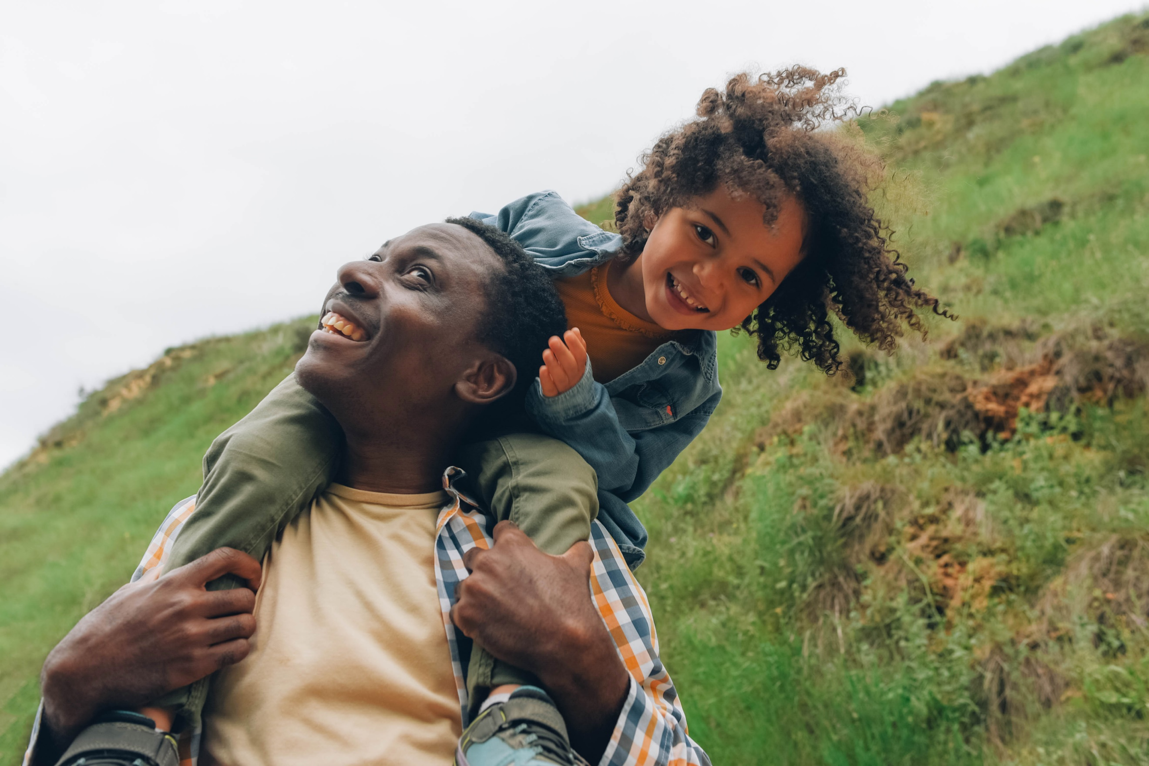 |  |  |  | Multidisciplinary Team Evaluation  Advocate: assists parents/guardians in ensuring student’s needs are met  Behavior Specialist: assesses etiology of behaviors, Functional Behavioral Analysis  School Nurse: reviews medical records, hearing/vision tests, consult/refer to outside doctors  Speech-Language Pathologist: screens for developmental speech/language challenges  Physical and Occupational Therapists: assess gross/fine motor functioning assessments, self-help, living skills  Audiologist: assesses hearing, recommend assistive technology  Officers of the Court: if the student is or was involved with juvenile justice system  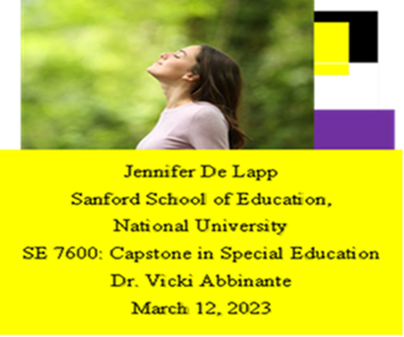

Multidisciplinary Team Evaluation
The STUDENT is the NUCLEUS
Their Perspective, Input, and Context
Parents or guardian: important allies who provide student’s history/background/needs
Classroom teachers: create optimal learning environments
Special education teacher: interviews parents/teachers, educational/perceptual tests, observes across contexts, recommends intervention/instructional strategies; administers diagnostic norm-referenced, criterion-referenced tests
School psychologist: administers aptitude tests, intelligence tests, personality inventories, observations across contexts
Administrator: ensures the evaluation process is meeting procedural and substantive standards of the law
School Social Worker: gathers/provides data on family systems through interviews, observations, conferences

Thorough Evaluation Processes  - Records  “Cum” files; academic achievement; test scores, standardized tests, attendance, teacher reports, discipline referrals; SST referrals, medical history, progress reports, program changes, CPS referrals  - Student & Parent collaboration  - Naturalistic Observations  - MTSS |  |  |  | Staff Education & Training  - Learn effective, evidence-based methods for curriculum building, instruction, & intervention  - Learn special education law  - Be aware of ambiguous socially constructed categories of disability  - Learn facts regarding disproportionate identification and overrepresentation  - Understand impacts of context factors: poverty, historical & present sociopolitical oppression and discrimination, multilayered and transgenerational trauma, home living conditions, community and neighborhood contexts  - Understand the impact of marginalizing those who do not fit the dominant cultural “norm, ” ableism, labeling, stigmatizing, & limiting potential  - Understand impact of trauma on neurobiological development, functioning, behavior, and learning  - Learn Restorative Justice, Social Justice & Equity, and Culturally Responsive Approaches |  |  |  | Staff Coaching & Support  - Introspection, self-reflection, and self-evaluation to identify biases, negative beliefs, erroneous assumptions and alter them  - Recognize personal triggers and choose responses over reactions  - Gather data and evaluate the efficacy of instruction and interventions and modify if necessary
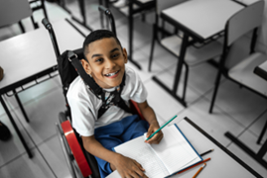  - Medical, hearing, & vision exams  - Classroom management, instructional, behavioral, & ecological assessments  - Norm & Criterion-Ref. tests  - Curriculum-Based Assessments  - Authentic assessment  - Task/work sample analysis  - Learning styles assessment  - Intelligence-aptitude tests  - Language-Perceptual abilities  - Social-Emotional skills  - Portfolio assessment  - Progress monitoring  - Rating scales/checklists |  |  |  |  |  |  |  | Reducing Bias in Assessment Improves Student Outcomes  - Reduces disproportionality and overrepresentation  - Improves student:  - academic achievement  - social-emotional skills-life functioning  - self-esteem  - school engagement  - academic attitudes  - wellbeing  - persistence  - ability to navigate discrimination  References  Bryant, D. P., Bryant, B. R., & Smith, D. D. (2020). Teaching students with special needs in inclusive classrooms (2nd ed.). SAGE.  De Lapp, J. (2023, March 5). Equity-centered trauma-sensitive interventions to prevent disproportionate identification and overrepresentation of marginalized populations in special education. Sanford School of Education, National University.  National Center for Learning Disabilities. (2020). Significant disproportionality in special education: Current trends and actions for impact. https://www.ncld.org/  Pierangelo, R., & Giuliani, G. (2008). Understanding assessment in the special education process. Corwin.

